Steven(10.12.1.36)-GhostIA

Sarah Ferenczi

Enumeration

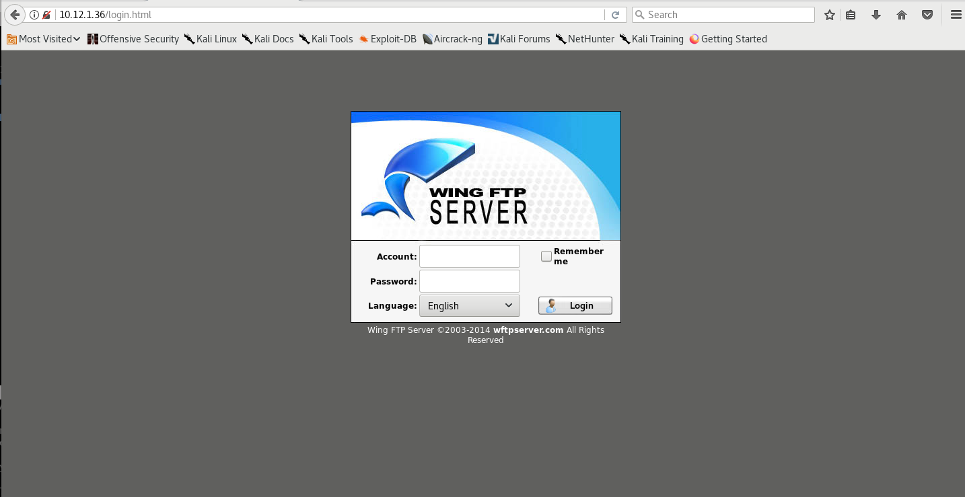

First let’s go and check the website, we can look and see if we can find anything interesting.

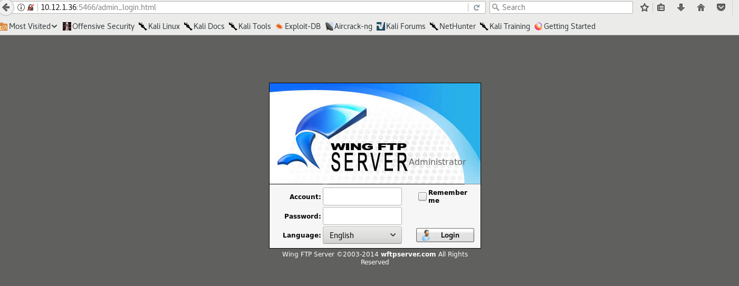

However, if we head to port 5466, we can find the admin panel.

Exploitation

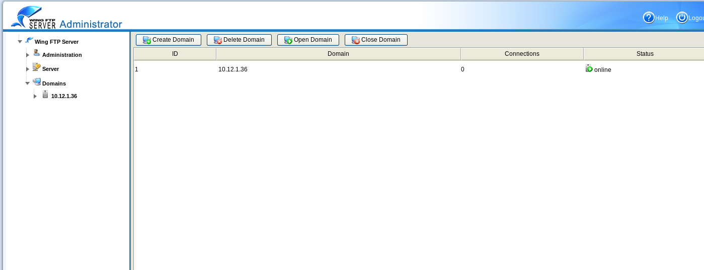

If we use the credentials admin/admin, we can access the webpage.

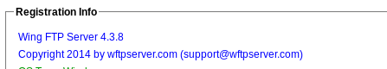

If we go to License, we can find the version number of this.

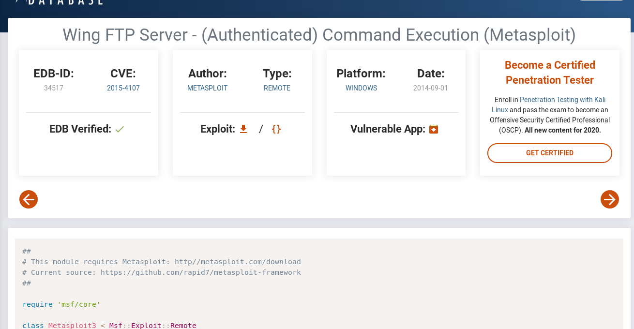

Then, we can go ahead and find an exploit related to this: a metasploit module.

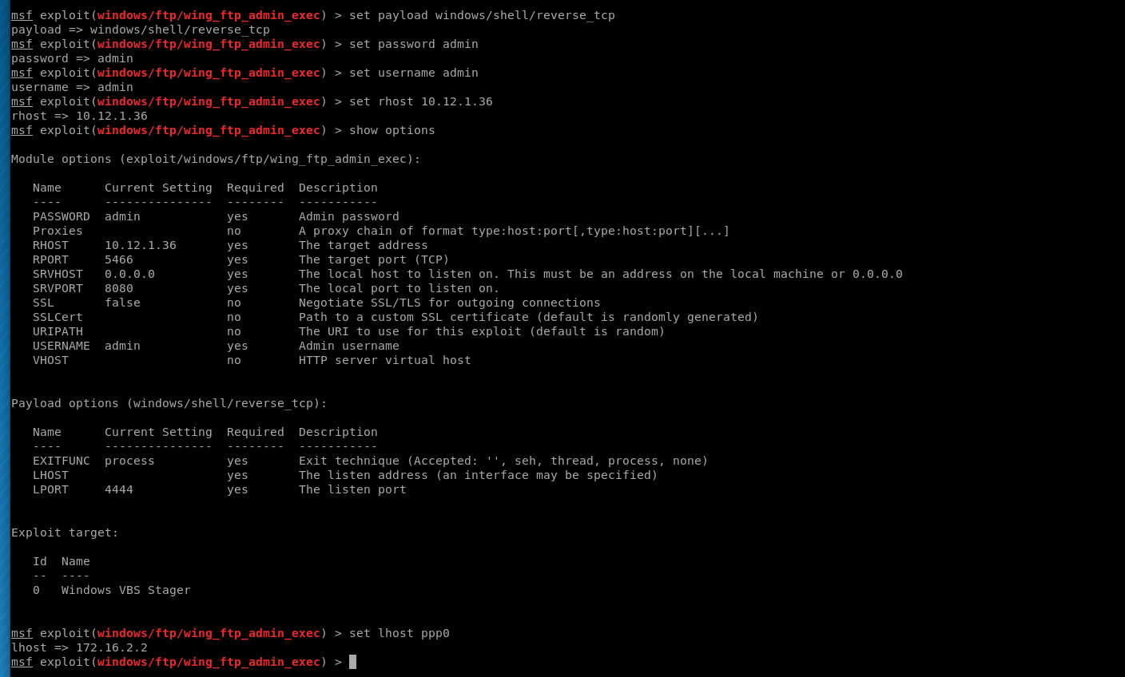

Then we can go ahead and set all of our options.

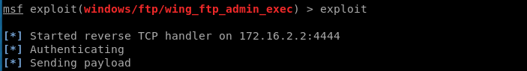

Then exploit.

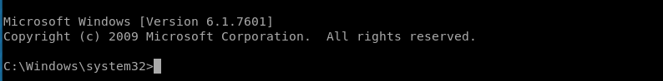

Now that we are in the system, we can go ahead and get the key.

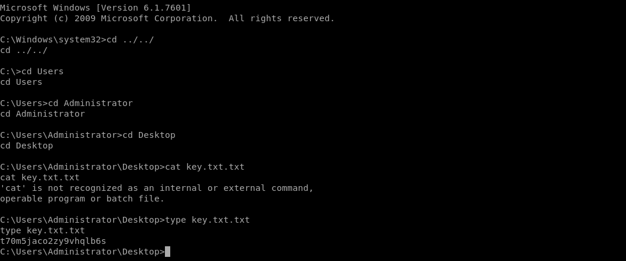

Now we can go ahead and get the key.